

**DEVELOPMENT OF EXPLAINABLE AI MODELS FOR**

**FINANCIAL RISK**

**ASSESSMENT**

**Written by**

**ABALAKA SAMUEL ILEANWA**

NASSARAWA STATE UNIVERSITY, STATISTICS**(INTERN)**

**AWAD IHIEZU ABDULMAJEED**

FEDERAL UNIVERSITY OF TECHNOLOGY MINNA, STATISTICS**(INTERN)**

**IKHUOHON-EBOREIME EUNICE NGOZI**

UNIVERSITY OF BENIN **(NYSC)**

**ABUBAKAR YUSUF JODA**

ABUBAKAR TAFAWA BALEWA UNIVERSITY **(INTERN)**

**General Overview**

Financial risk management encompasses the determination, assessment, and mitigation of risks that can affect financial assets or institutions in a negative manner. Four key categories of risk have been identified: credit risk, market risk, operational risk, and liquidity risk. Traditional risk management has relied on deterministic models and rule-based systems. Then comes the advent of machine learning, or ML, and AI, which has transformed it by offering predictive accuracy and dynamic adaptation.

While there are these advantages, the major challenge with AI systems in finance involves their "black-box" nature that eventually leads to issues in trust, interpretability, and regulatory compliance. Explainable AI addresses this with methods that ensure models are effective, interpretable, and transparent, making them appropriate for high-stakes domains such as finance.

**Statement of the Problem**

Financial institutions, including asset managers, fleet operators, and logistics firms, heavily depend on risk assessment models to manage critical decisions such as financing, investment planning, asset allocation, and fraud prevention. However, traditional models often fail to capture the intricate and dynamic nature of financial markets and operational risk in sectors like fleet management. This can result in inaccurate predictions, inefficient resource allocation, and significant financial or compliance-related losses

While AI and ML technologies are improving predictive capability, many of these models suffer from the "black-box" problem of limited interpretability, which, in turn, limits their adoption. A lack of transparency is very problematic to meet regulatory compliance and to gain stakeholder trust in regulated industries where explainability is core to accountability.

These solutions, ranging from rule-based systems and statistical models to traditional machine learning algorithms, all suffer from one or more of the following limitations:

* **Accuracy:** Inability to adapt to rapidly changing economic or operational conditions.
* **Transparency:** Limited capability to provide insightful interpretability for decision-makers or regulators.
* **Scalanability:** Incompatibility with modern asset management and fleet systems for tracking vehicle health or operational expenses.

**Proposed Solution**

This research is, therefore, dedicated to the design and development of XAI models for financial and operational risk management in asset-heavy industries, such as fleet management. The models should be able to provide accurate predictions with interpretable insights for transparency in decision-making. By leveraging state-of-the-art AI/ML algorithms along with XAI techniques such as **SHAP (Shapley Additive Explanations), LIME (Local Interpretable Model-agnostic Explanations), and counterfactual explanations**, these models will enable stakeholders to:

Understand the key drivers of risk predictions, such as high fuel costs, late repairs, and market volatility. Make truly informed decisions that balance risk, profitability, and compliance. The project will be focused on:

* Developing a hybrid model that combines advanced AI/ML methods with interpretable outputs tailored to fleet and financial operations.
* Evaluating the performance of models in terms of predictive accuracy and interpretability against more traditional black-box approaches.
* Assess the impact on decision-making through simulations and real-world pilots in risk-intensive scenarios, such as loan approval, asset utilization, and fraud detection.

**Research Gaps in Explainable AI (XAI) for Financial Risk Management**

Despite the increasing interest and development in the application of Explainable AI to financial risk management, there are still considerable research gaps. These stand in the way of practical and widespread adoption of XAI models in high-stakes financial domains, especially with regard to balancing accuracy, interpretability, and regulatory compliance.

Identified Research Gaps:

**Limited Real-World Deployment of XAI Models:**

Most research on XAI remains theoretical or confined to experimental datasets.

Lack of studies proving the efficiency of XAI in operational financial environments such as credit scoring, fraud detection, or asset risk management.

**Trade-off Between Accuracy and Interpretability:**

Complex models, for example, deep learning, are accurate but less interpretable.

Simple models, for example, decision trees, are interpretable but lack predictive power in dynamic financial scenarios.

**Lack of Suitable Frameworks:**

Few frameworks customize XAI methods to meet the specific needs of financial stakeholders, including regulators, analysts, and customers.

**Bias and Fairness Concerns:**

Fairness in XAI applications is not well explored, especially regarding model bias in credit decisioning or market risk analysis.

**Integration Challenges:**

Inability to integrate XAI models with the existing financial risk management system due to the presence of legacy technologies and processes.

**Lack of Comprehensive Evaluation Metrics:**

No standardized approach to quantifying the success of XAI models in terms of predictive accuracy and explainability.

**Ethical and Governance Frameworks:**

Lack of focus on the development of ethical guidelines and governance structures for XAI in finance, in particular, under the new emerging regulations such as the EU AI Act.

**Graphical representation of the Research Gaps**

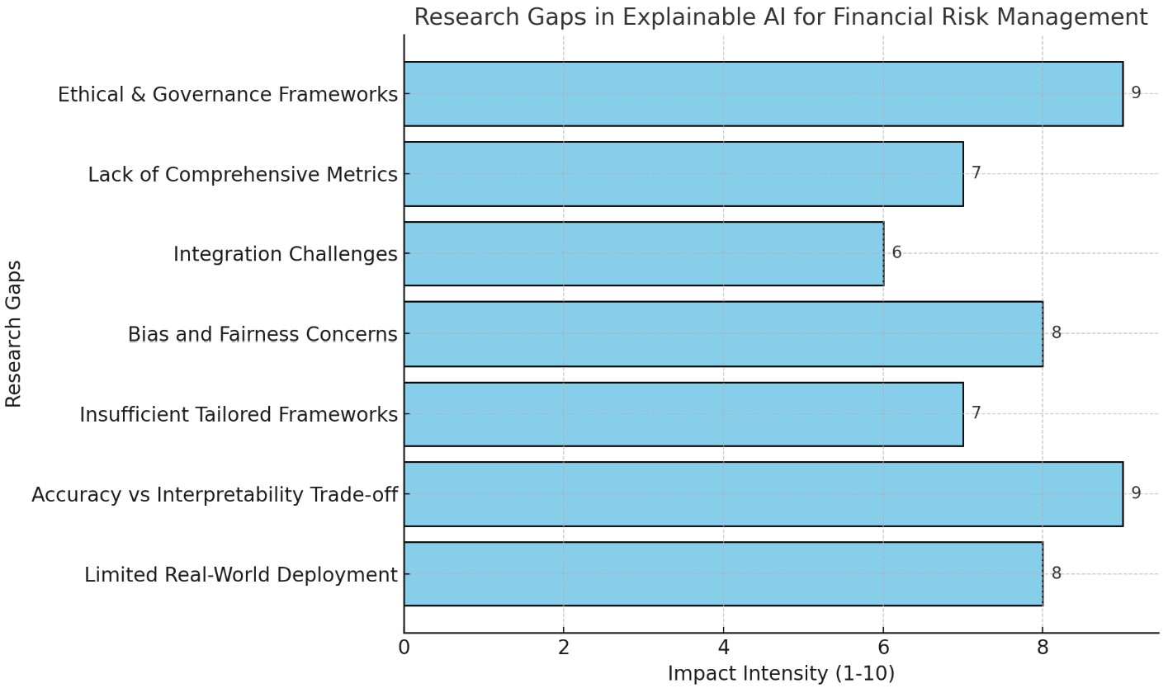

**Devised Methodology**

Study will be composed of the following

1. **Data Collection**: Gather a representative financial dataset, ensuring data privacy and compliance with regulatory standards. This may include credit scores, transaction histories, loan repayments, or other relevant financial metrics.

2. **Model Selection and Development:** Deploy traditional black-box models based on deep learning and interpretive models based on decision trees. Try out hybrid models that balance performance with interpretability.

3. **Explanation Techniques:** Integrate XAI techniques, such as SHAP, LIME, and counterfactual explanations, to interpret the models. Evaluate and refine the explanations so that they are understandable and useful for financial decision-makers.

4. **Evaluation and Validation:** It evaluates model accuracy and performance by metrics such as AUC, precision, and recall. Qualitative evaluations are performed through the interpretation and assessment of model explanations by financial professionals. Comparison of explainable models with black-box models.

5. **Impact Analysis:** Examine how stakeholders respond to the explanations provided by the XAI model. Assess whether it is effective in enhancing decision-making, trust, and regulatory compliance.

**Significance of Study**

The present research study tries to enhance financial risk management, AI, and XAI by addressing various challenges that limit the application of advanced AI in finance. These findings are imperative for financial institutions, regulators, and researchers. The main importance areas include:  
  
1. **Financial Risk Management: An Overview**  
The integration of XAI with machine learning is going to greatly serve interpretability in applications related to credit risk, fraud detection, and market trend prediction.  
It emphasizes the need for explainable AI in decision-making, which would cut financial losses and improve efficiency.  
2. **Regulatory Compliance**  
The study provides a framework for explainable models that meet new regulations such as the EU AI Act, with an emphasis on fairness, transparency, and accountability.  
It provides model interpretability tools to financial institutions, enabling them to build trust with regulators and customers.  
3. **Fostering Ethical AI Practices**The research promotes ethical AI on issues of fairness and bias, ensuring that all are treated equitably with regard to different demographic and behavioral groups. The study calls for responsible use of AI, a must for public trust in automated decisions.  
4. **Stakeholder Impact**  
With its user-friendly dashboards and clear insights, this will enable financial analysts and decision-makers to make informed data-driven choices.  
This research aims at developing the means for integrating state-of-the-art AI into financial systems while addressing legacy compatibility and operational complexity.  
5. **Contribution to Research and Innovation**  
This study relates XAI academic advancements to their application in practice for financial risk management. It sets a precedent for future studies in interpretable AI applied to high-stakes fields, such as healthcare, legal compliance, and cybersecurity.  
6. **Active Risk Management**  
The research enables real-time risk assessment and proactively mitigates it with advanced AI. It helps organizations to identify financial threats in advance, improving resource allocation and risk management. This research provides a practical framework to integrate XAI into financial risk management, which can overcome the current challenges and pave the way toward more transparent and efficient financial systems.

**Overview of related works**

|  |  |  |  |  |  |  |  |
| --- | --- | --- | --- | --- | --- | --- | --- |
| S/N | Author(s) & Year | Title | Methodology | Result | Proposed approach | Limitations | Contributions |
| 1 | Moses Alabi & Ai Wen Ang (2024) | AI-Driven Financial Risk Management: Detecting Anomalies and Predicting Market Trends | Explored supervised/unsupervised learning for anomaly detection, NLP for sentiment analysis, reinforcement learning for strategies. | AI enhances anomaly detection, market trend forecasting, and decision-making speed, aiding proactive risk mitigation. | Integration of AI with traditional frameworks to improve risk assessments. | Ethical concerns like data privacy and risk amplification from AI misuse. | Showcases the advantages of AI in improving speed, accuracy, and reliability in financial risk management. |
| 2 | Paolo Giudici (2018) | Fintech Risk Management: A Research Challenge for Artificial Intelligence in Finance | Investigates big data, AI, and blockchain in fintech risk management; suggests graphical models for systemic risk. | Improved P2P lending credit scoring using correlation networks; automation reduces barriers between fintechs and supervisors. | Use of big data analytics for systemic risk monitoring and blockchain for transaction verification. | Limited generalization of findings to traditional financial markets; lacks scalability framework for integration. | Provides a roadmap for RegTech/SupTech adoption and systemic risk management in fintech ecosystems. |
| 3 | Fritz-Morgenthal, Hein, & Papenbrock (2022) | Financial Risk Management and Explainable, Trustworthy, Responsible AI | Discussed EU AI Act requirements; emphasized model governance, fairness, and the application of SHAP for explainability in credit risk models. | XAI improves transparency and regulatory compliance, ensuring fairness in credit decisions. | Tailoring XAI approaches to stakeholder needs while leveraging SHAP and LIME for post-hoc explanations. | XAI cannot fully address the black-box nature of ML; computational resource demand for explainability techniques. | Highlights the need for governance frameworks and the role of XAI in ensuring regulatory alignment and public trust. |

**References**

• **Alabi, M., & Ang, A. W.** (2024). AI-driven financial risk management: Detecting anomalies and predicting market trends. Journal of Financial Technology, 6(1), 1-15. https://doi.org/10.1007/AI1-001

• **Giudici, P.** (2018). Fintech risk management: A research challenge for artificial intelligence in finance. Frontiers in Artificial Intelligence, 1, 1-7. <https://doi.org/10.3389/frai.2018.00001>

• **Fritz-Morgenthal, S., Hein, B., & Papenbrock, J.** (2022). Financial risk management and explainable, trustworthy, responsible AI. Frontiers in Artificial Intelligence, 5, 779799. <https://doi.org/10.3389/frai.2022.779799>